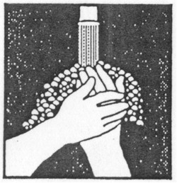

**UNIVERSAL PRECAUTIONS**

**NOTICE**

All employees and visitors must follow precautions listed below (as they may apply), as well as other instructions that may be issued by the Infection Control Coordinator, Director of Nursing, and/or the Medical Director

1. Avoid direct exposure to resident's blood, excretions, secretions, mucous membranes, and non-intact skin.

1. Avoid needlestick or razor injuries
2. All items soiled with blood or contaminated materials must be handled as infectious waste.
3. Refer to the Infection Control Manual for appropriate isolation procedures.
4. Report to licensed staff all exposures to blood/body fluids, that likely contained blood.

**Handwashing Gloves Gown Mask Goggles**

After providing care When exposure to If soiling of If splashing of If splashing of blood

or touching items blood or body clothing is blood or body or body fluids is likely

contaminated with fluids is planned likely fluids is likely to to the eyes

blood or body or anticipated. nose or mouth

fluids.

1997 CDC Guidelines