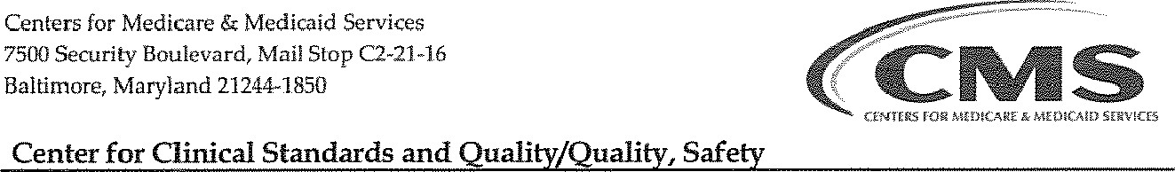& ()versight
DEPARTMENT
OF
HEALTH
&
HUMAN
SERVICES
Group
Nursing Home Provider Entrance Letter
TO: LTC Administrator
FROM: Dr. Daniel Schwartz, CMS:
SUBJECT: Infection Control Pilot Project
The Centers for Medicare & Medicaid Services (CMS) is conducting a pilot project to improve assessment of control and prevention in Long Term Care facilities (LTC) which care for ventilator dependent residents. This unannounced on-site pilot survey of your LTC will föcus primarily in the area of Infection Control. A contracted surveyor and infection preventionist from Healthcare Management Solutions (HMS) will be conducting the pilot survey using a survey process based on the new Long Term Care regulations.
This pilot survey is anticipated to take place over the next two days and your participation is a unique opportunity to help improve resident safety. It is intended as an educational survey, meaning that there will be no CMs-2567 created and no citations issued. However. if an Immediate Jeopardy is identified, the survey team will communicate with the CMS Regional Office and official survey activities could be initiated.
An Entrance Conference will be conducted at the start of the survey, and a brief Exit Conference will be conducted at the end. The survey team will be assessing the infection prevention and control program through observations, interviews, and record reviews based on the new survey process. The results of the survey will be shared by the survey team informally at the exit conference.
Hopefully, your facility will find this experience to be an opportunity to improve quality of care. I understand the inconvenience this survey may cause your facility as CMS looks för ways to improve our survey process and I appreciate your willingness to participate. If you have any to improve this pilot survey, please feel free to contact me. Thanks for your understanding!
Sincerelv,
Daniel Schwartz, MD
Physician
Quality, Safety, & Oversight Group
CMS
443-797-2644

